


srj.susanjohnson@gmail.com

Managing multiple priorities

www.thrivingamidstchaos.com

Topics

 Core tool: An effective to-do system

 Core strategy: Engage regularly with MIP’s Core habit: Weekly & daily tactical plans

Topics

Core tool: An effective to-do system
Core strategy: Engage regularly with MIP’s Core habit: Weekly & daily tactical plans

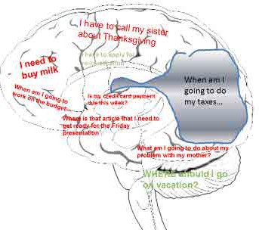
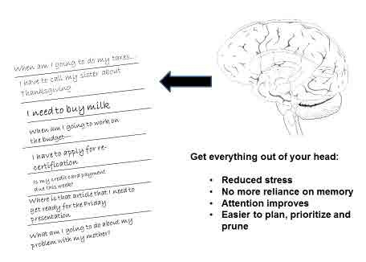
The solution: A effective “distributed cognition system” for storing to-do’s in order to support prospective memory:
- Calendar
- Lists
- Physical and recorded reminders

~4 items only
- Can’t prioritize: Later=now Unimportant=important Maybe=for sure

The Zeigarnik effect

- A single calendar with all your time commit=ments
=
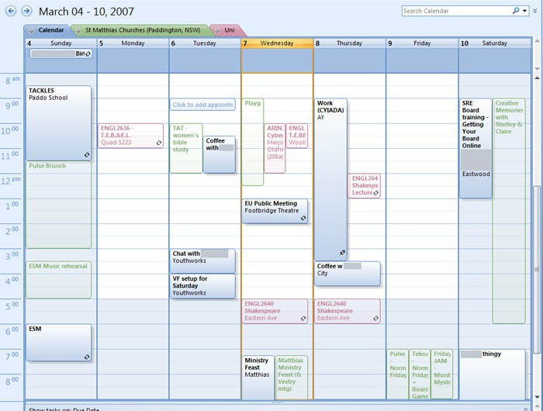

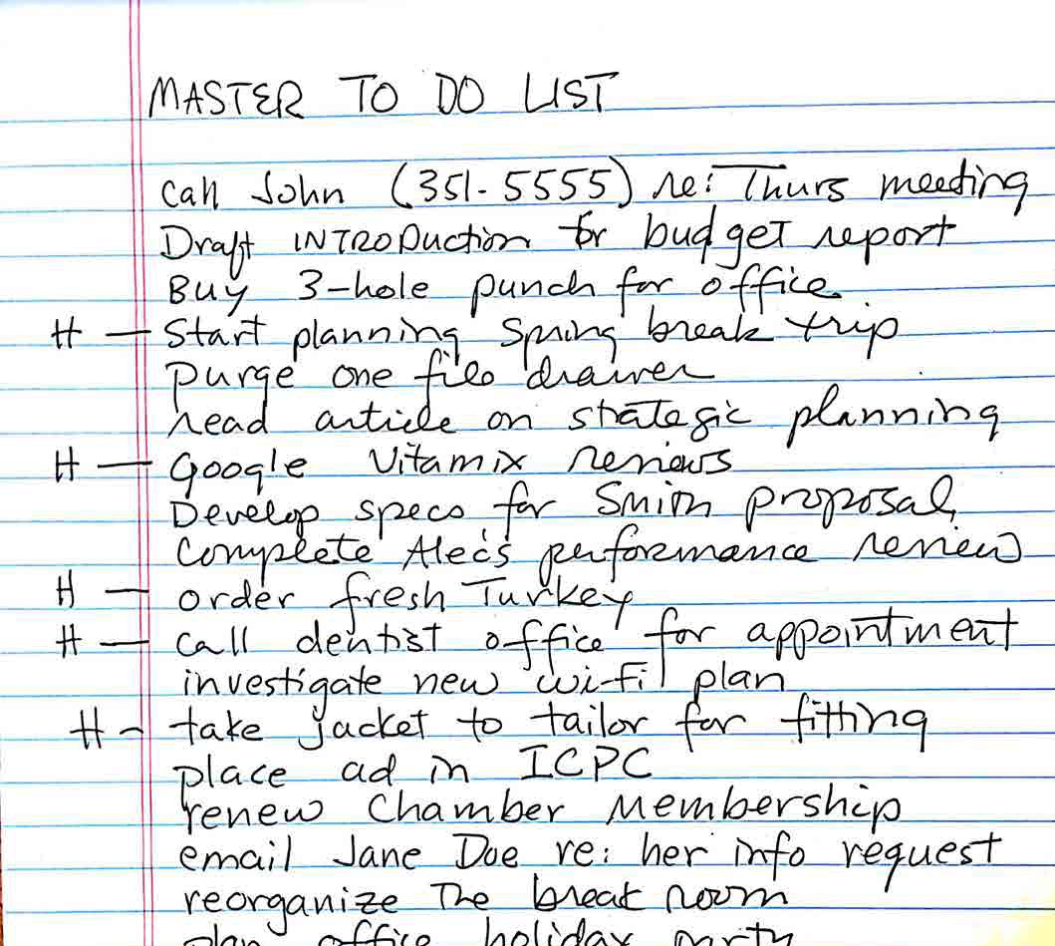
A single* master to-do list

Avoid poorly defined to-do list items:

  - Too vague: e.g. “call Mary”
    - Instead: “Call Mary (333-4444) to schedule lunch for next Wednesday to discuss new committee”

  - Some items are too big: e.g. “K-application”
    - Instead: “Spend one hour drafting Aim 1 for K”
    - Consider keeping a separate list of projects

description
sister to check on dates

Project List  PERSONAL  Plan Dad’s 80th birthday party | Task List
Project List  PERSONAL  Plan Dad’s 80th birthday party | - Email my
WORK  Hire research assistant | - Draft job

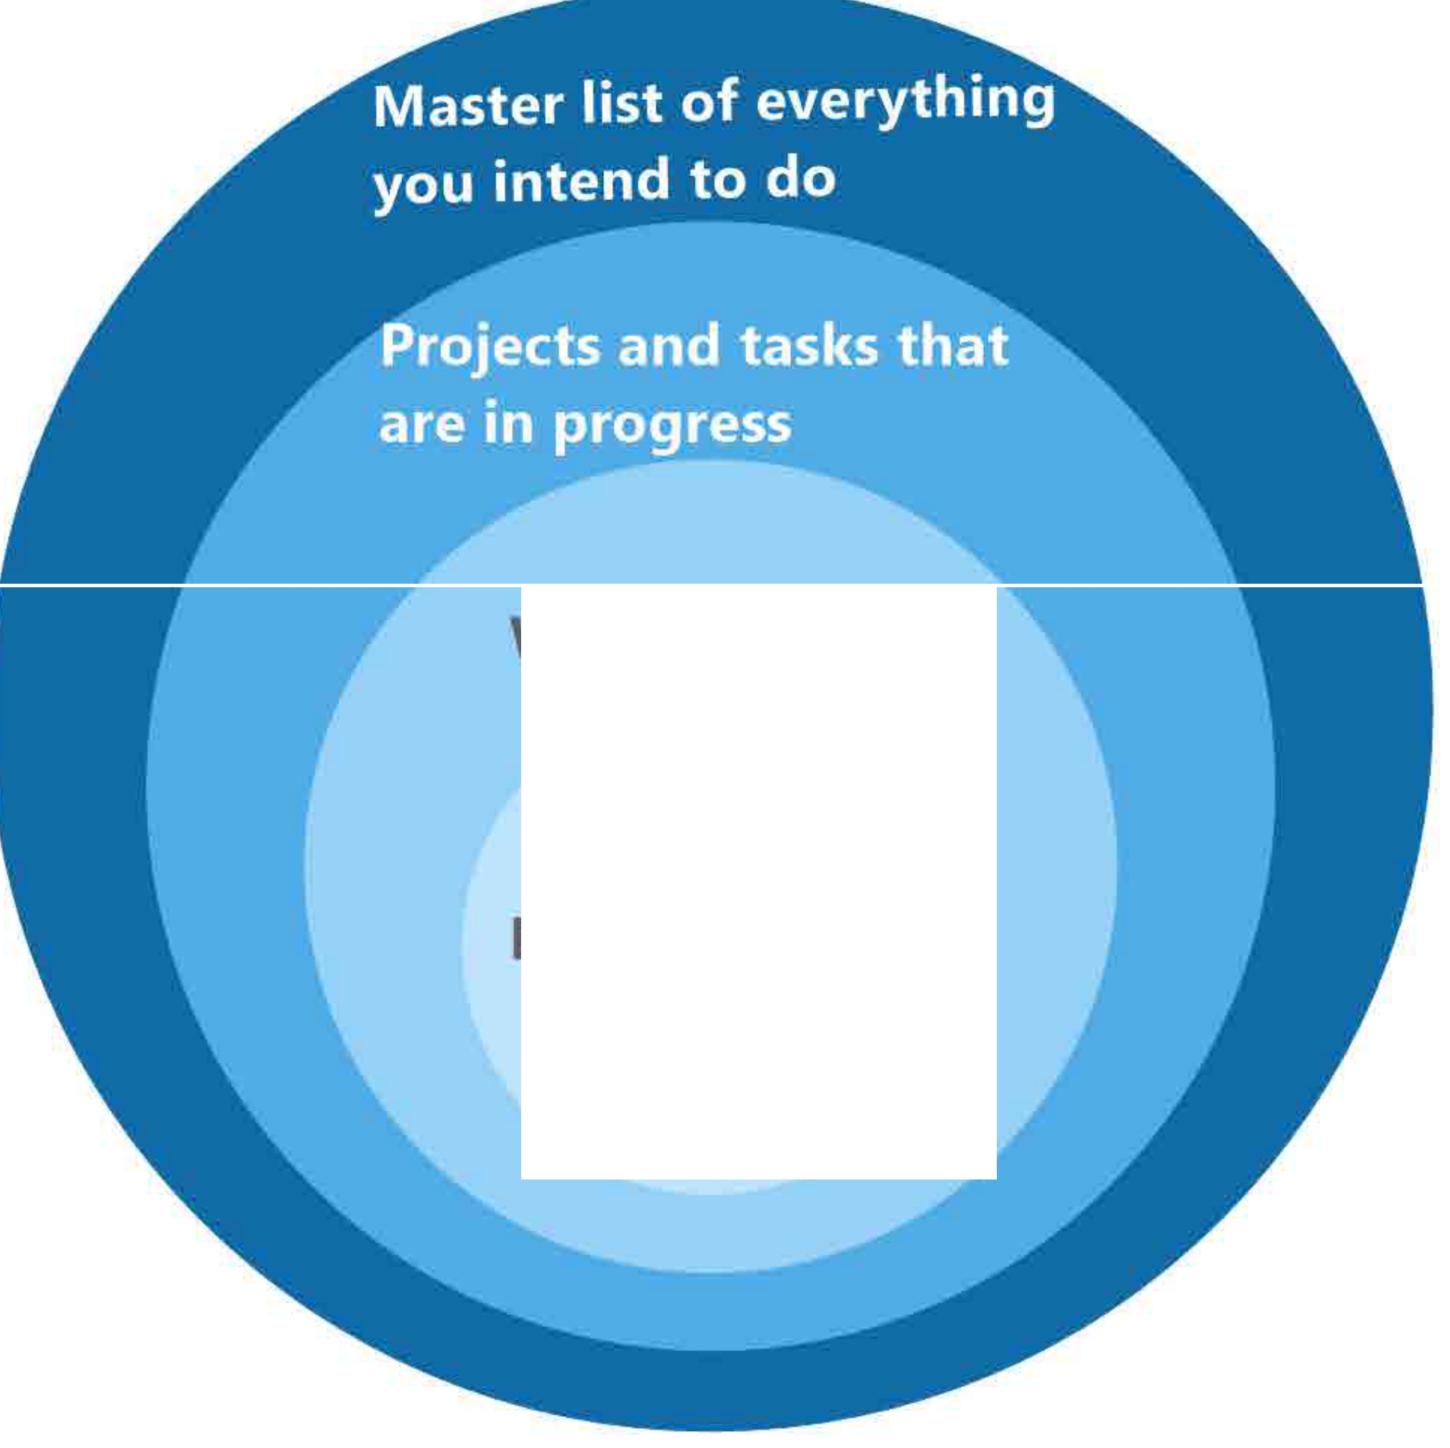

Weekly task plan

Daily task plan

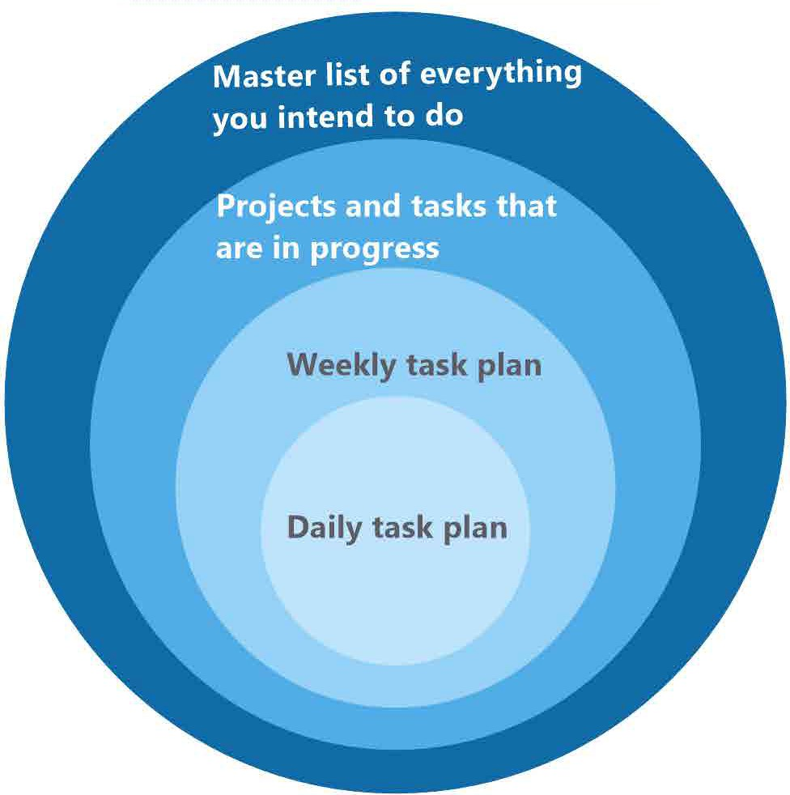


?? Ideas you may want to pursue later….

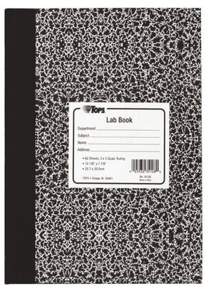
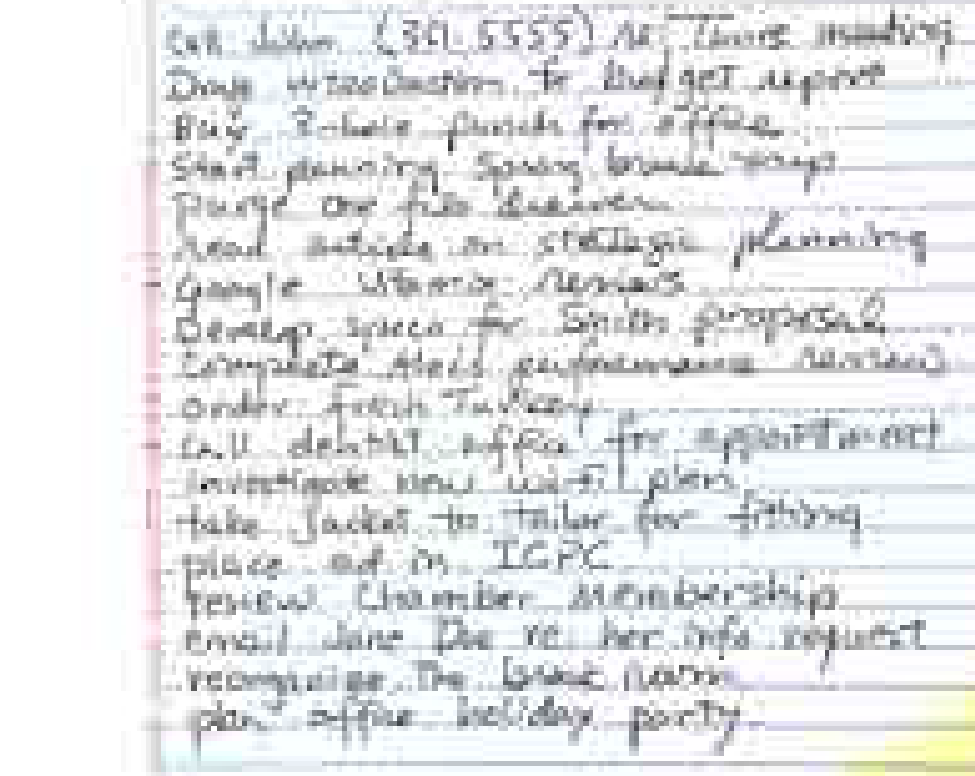
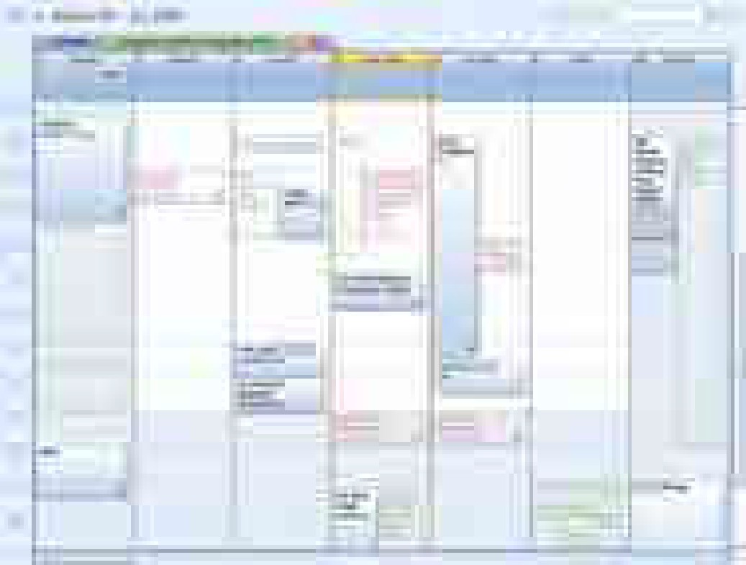
- A storage system for ideas to consider later
Ideas for later
Work you might
do, someday
Storage options:
Research ideas for later
* Reminder?
calendar
list / file/ folder

Work that you
intend to do
Master list

?? IDEAS TO CONSDER LATER

Topics

Core tool: An effective to-do system

Core strategy: Engage regularly with “MIP’s”
Core habit: Weekly & daily tactical plans

MIPs?
- most important projects
-what are yours?

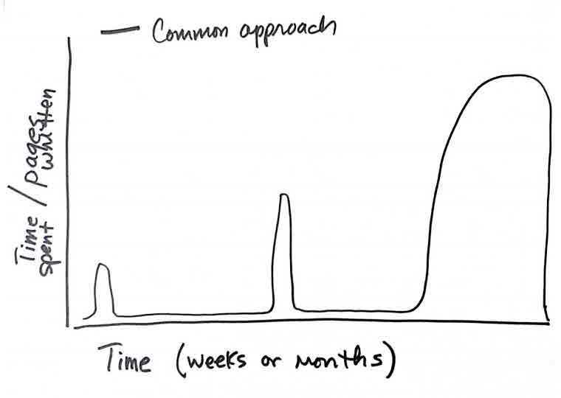

Scenario 1:
With a deadline

Scenario 2:
Without a deadline



“…[make] real progress every single day.”
-- John Kotter (2008). A Sense of Urgency
Konosuke Matsushita Professor of Leadership, Emeritus at the Harvard Business School

A brief history of academic writing advice
- Pre- Boice
- 1980s: the Boice data
- Post- Boice:
  - “write every day in moderate sessions”
- 2011-2015: the Sword data

Helen Sword (2017). “Only 1 in 8
Air & Light & Time & Space, wrote every day.”
Harvard University Press

“Write every day”

Word count
- Recency effect

Write regularly, for long enough to make progress, and frequently enough to stay engaged.

Parameters?
- Interval between sessions: </= a week
- Session length: sufficient to keep on track
(? ~3-5 hours/week = 45-60”/d)



Try:
At the start of the work day, work on an MIP before you do anything else

Or, find your best time do it

Schedule time blocks
8
8

Mon

Have a goal for the block & a simple action to get started.

12

** Focused Work **

5

Plan a starting task for the next session, then stop

Time Block:
3 different scheduling plan approaches

 | Mon |  | Tues | Wed |  | Thur | Fri |  |  | Sat | Sun
6:00
7:00 |  |  | Project |  | (same time | every day)
8:00
9:00 |  |  |  |  |  |  |  | Project
10:00 |  |  |  |  |  |  |  | Project
 |  |  |  |  |  |  |  | (one big
11:00 |  |  |  |  |  | Project  (ad hoc) |  | chunk per
 |  |  |  |  |  |  |  | week)
12:00 |  |  |  |  |  | Project  (ad hoc) |  | week)
1:00
2:00
3:00 |  | Project |  |  | Project
4:00 |  | (office) |  |  | (library)
5:00
6:00
7:00
8:00
9:00

Scheduled time block alternative:
… based on Neil Fiore’s “unschedule” method.

6:00
7:00
8:00
9:00
10:00
11:00
12:00
1:00
2:00
3:00
4:00
5:00
Mon

Keys:
Tues
Wed
Thur
Fri
Sat
Sun

6:00
7:00
8:00
9:00
10:00
11:00

Set an intention to do MIP work at the beginning of the week (or day)
- Decide exactly what you will do when time is available

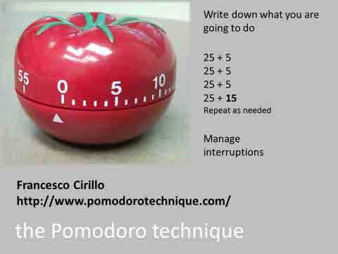

* Check your play store for a Pomodoro phone app

Topics

Core tool: An effective to-do system
Core strategy: Engage regularly with MIP’s

Core habit: Weekly & daily tactical plans

At the beginning of the week:

– Sketch a plan for overall time use that supports your whole life

Plan work boundaries & personal / social activities
Week of:

 | Monday | Tuesday | Wednesday | Thursday | Friday |  | Saturday | Sunday | `
0600 |  |  |  |  |  |  |  |  | `
 | Exercise |  |  |  |  |  |  | Calls with | `
0700 |  |  |  |  |  |  |  | family | `
0800 |  |  |  |  |  |  |  |  | `
 |  |  |  |  |  |  |  | Bike | `
0900 |  |  |  |  |  |  |  |  | `
 |  |  |  |  |  |  |  | ride | `
1000 |  |  |  |  |  |  |  |  | `
 |  |  |  |  |  |  |  | laundry | `
1100 |  |  |  |  |  |  |  |  | `
1200 | Lunch |  |  |  |  |  |  | cleaning | `
1300 |  |  |  |  |  |  |  | Friends | `
 |  |  |  |  |  |  |  | birthda | `
1400 |  |  |  |  |  |  |  | y party | `
1500 |  |  |  |  |  |  |  |  | `
 |  |  |  |  |  |  | groceries |  | `
1600 |  |  |  |  |  |  |  |  | `
1700 |  |  |  |  |  |  |  |  | `
1800 |  |  |  |  |  |  |  |  | `
 |  |  | dinner |  | dinner |  |  | Eat out | `
1900 | dinner | dinner |  | dinner |  |  | dinner |  | `
 |  |  |  |  |  |  |  | With | `
2000 |  |  |  |  |  |  |  | friends | `
 |  |  |  | Movie |  |  |  |  | `
2100 |  |  |  |  |  |  |  |  | `
 |  |  |  | PTO  night |  |  |  | Day OFF

At the beginning of the week:

- Review and update your to-do list(s)

- Review your calendar(s) 3+ weeks forward

- Identify at least ONE chunk of MIP work that you want to complete in the coming week

At the beginning of the day:

- Ask yourself what you would like to accomplish in addition to scheduled and routine work – focus on MIPs

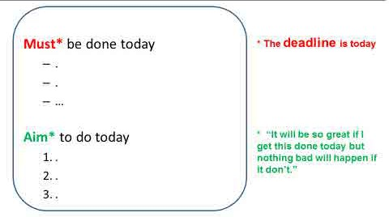
Daily: MIT list

(highest priority work task)

Productivity Resources: general time management /organization/ productivity
David Allen (2105). Getting Things Done: The art of stress free productivity, 2nd edition
A popular, effective, comprehensive workflow and planning system. If you aren’t sure about buying the book, go to https://www.dandywithlens.com/getting-things-done-gtd/ for a brief overview of this system

Michael Hyatt (2019). Free to Focus.
This book covers goal setting, planning, and executing to reach those goals and other relevant topics.
NOTE: IMHO, the combo of Free to Focus and Getting Things Done provides a complete productivity system.

Michael Linenberger. The One Minute To-do List (https://www.michaellinenberger.com/free1MTD.htm )
You can request a free pdf download of this book at the link above. The method is an effective way to create and manage your to-do (task) list, and can be used either as a stand alone, or as a complement to the GTD next action list method

Laura Vanderkam (2015). I Know How She Does It: How Successful Women Make the Most of Their Time
Vanderkam is a journalist and author who became interested in how people spend their time, and now writes books about successful strategies. This book focuses on the actual experiences of a group of 100 women who have busy professional careers and children at home, and who kept time diaries for a week. Vanderkam analyzed the diaries and identified strategies these women use to be successful in both spheres. Not just for women!

Cal Newport (2012) So Good They Can’t Ignore You: Why Skills Trump Passion in the Quest for Work You Love
Newport wrote this book as he was finishing his postdoctoral fellowship at MIT, at a time that he was contemplating his own career path as a theoretical computer scientist. He researched the idea that you should “follow your passion,” and in this book explains that that is not the best approach, and what you should do instead. Relevant for anyone at the beginning of their career, or for those considering a career change.

http://www.asianefficiency.com/
The Asian Efficiency group offers a wide range of both free and fee based resources (newsletter, podcasts, videos, white papers, courses), and they include most all of the effective systems, trips, and strategies – a “one stop shopping” resource

Productivity Resources: Writing

Jensen and Silvia recommend the same core advice: write nearly every day, but each then covers additional issues not included by the other. Between these two books, the topic is covered completely.

Paul J. Silvia (2018, second edition). How to Write a Lot: A Practical Guide to Productive Academic Writing.
Silvia is an academic psychologist, and this book is perhaps the most popular in this genre. This second edition reflects the authors new status as a dad with young children (making his advice about finding time to write more realistic). The book has has been updated to apply to a wider variety of disciplines, and has a new chapter devoted to grant and fellowship writing.
Joli Jensen (2017). Write No Matter What: Advice for Academics, The University of Chicago Press
The academic world Jensen describes is that of a liberal arts and sciences university (she is a communications studies professor) but the advice applies equally well to health science faculty and trainees. She sends the same message as Siliva - write nearly every day - but covers some additional reasons for resistance and has different views on some issues. She provides welcome detail on writing accountability group options, and how to deal with stalled projects .

Cal Newport (2016). Deep Work: Rules for Focused Success in a Distracted World, 2016
  - Detailed strategies for planning time to write, with emphasis on time blocking.
  - See also, Study Hacks blog: Cal posts about “deep work” and other productivity topics: http://calnewport.com/blog/

Gina Hiatt. The Academic Ladder: blog on academic writing http://academicladder.com/

Joan Bolker (1998). Writing your dissertation in fifteen minutes a day. New York, Henry Holt and Company, 1998
- A short introduction to “writing” every day.

Neil Fiore (2007). The Now Habit, 2007
  - Practical approaches to procrastination

srj.susanjohnson@gmail.com

Contact me anytime with questions or comments, and, get articles on my website

www.thrivingamidstchaos.com

