Agenda: bit.ly/GRAD201

- Lecture: Why and how to develop an independent research program (20 minutes, 10:10-10:30)
- Faculty perspective 1: Planning and selecting your projects as a graduate student. (30 minutes, 10:35-11:05). Isha Jain, PhD. Sandler Faculty Fellow, Principal Investigator.
- Faculty perspective 2: Developing and funding your independent research program as an international postdoc. Ernesto Diaz-Flores, PhD. Assistant Adjunct Professor, Department of Pediatrics. (20 minutes, 11:10-11:30)
- Lecture: Getting started: Designing your research project. Ernesto Diaz-Flores (20 minutes, 11:30-11:50)
- Working lunch: Write your one-page research plan (30 minutes, 12:00-12:30)
- Group work: Get feedback on your plan (45 minutes, 12:30-1:15)
- Faculty perspective 3 & Lecture: Using faculty feedback to improve the fundability of your research program. Felice Dunn, PhD, Assistant Professor (1 hour, 1:15-2:15)
- Break (10 minutes)
- Workshop: Your plan for identifying and reaching out to faculty (40 minutes, 2:25-3:05)
- Wrap up and assignment (15 minutes, 3:05-3:20): Giving a chalk talk.

Course Objectives: bit.ly/GRAD201

- Describe the research program expectations that faculty hiring committees have of candidates
- Describe the successful components of a research program
- Identify a unique research niche that would distinguish them from other scientists in the ﬁeld
- Identify mentors and collaborators that would allow them to develop this unique research niche
- Present their research program in the form of both a research statement and a chalk talk

1 2 3 4 5

I understand the research program expectations that faculty hiring committees have of candidates
Where are you in your development?
bit.ly/GRAD201A
I can describe the successful components of a research program
I have identiﬁed a unique research niche that would distinguish me from other scientists in the ﬁeld
I have developed a research proposal with speciﬁc aims
I have presented my proposal to faculty (in writing or orally) and have received critical feedback that can help me improve it

ow  1. | to use this wo  Understand what makes a research program successful | rkshop series  If you are a graduate student:  Identify success metrics for your search for the right postdoc environment | If you are a postdoc:  Build your strategy to discuss independence with your PI
2. | Begin deﬁning your vision & strategy for  your future lab
3. | Develop a network of faculty mentors who can oﬀer  critical feedback
4. | Practice presenting your research plan to peers
H

Why and how to develop
an independent research program
Laurence Clement

Research-Intensive Institutions (R)
Research & Teaching Focused (RT)
Teaching-Only

Institutions (T)


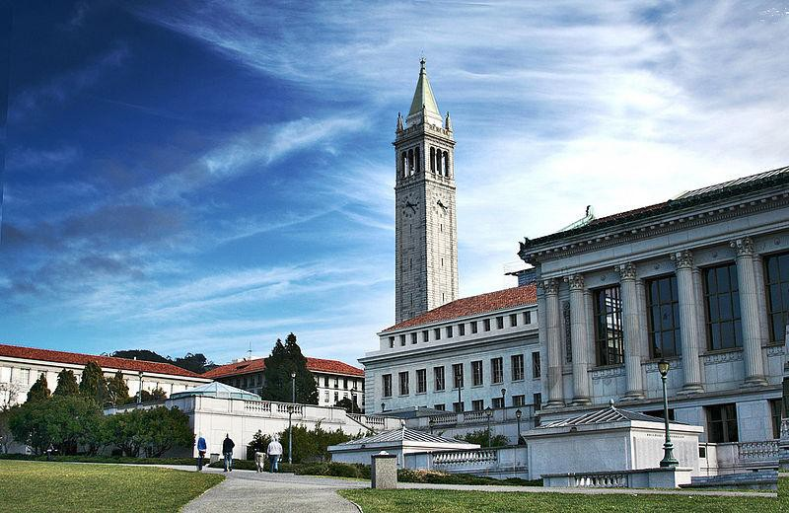
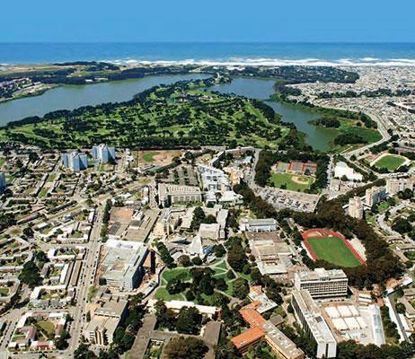
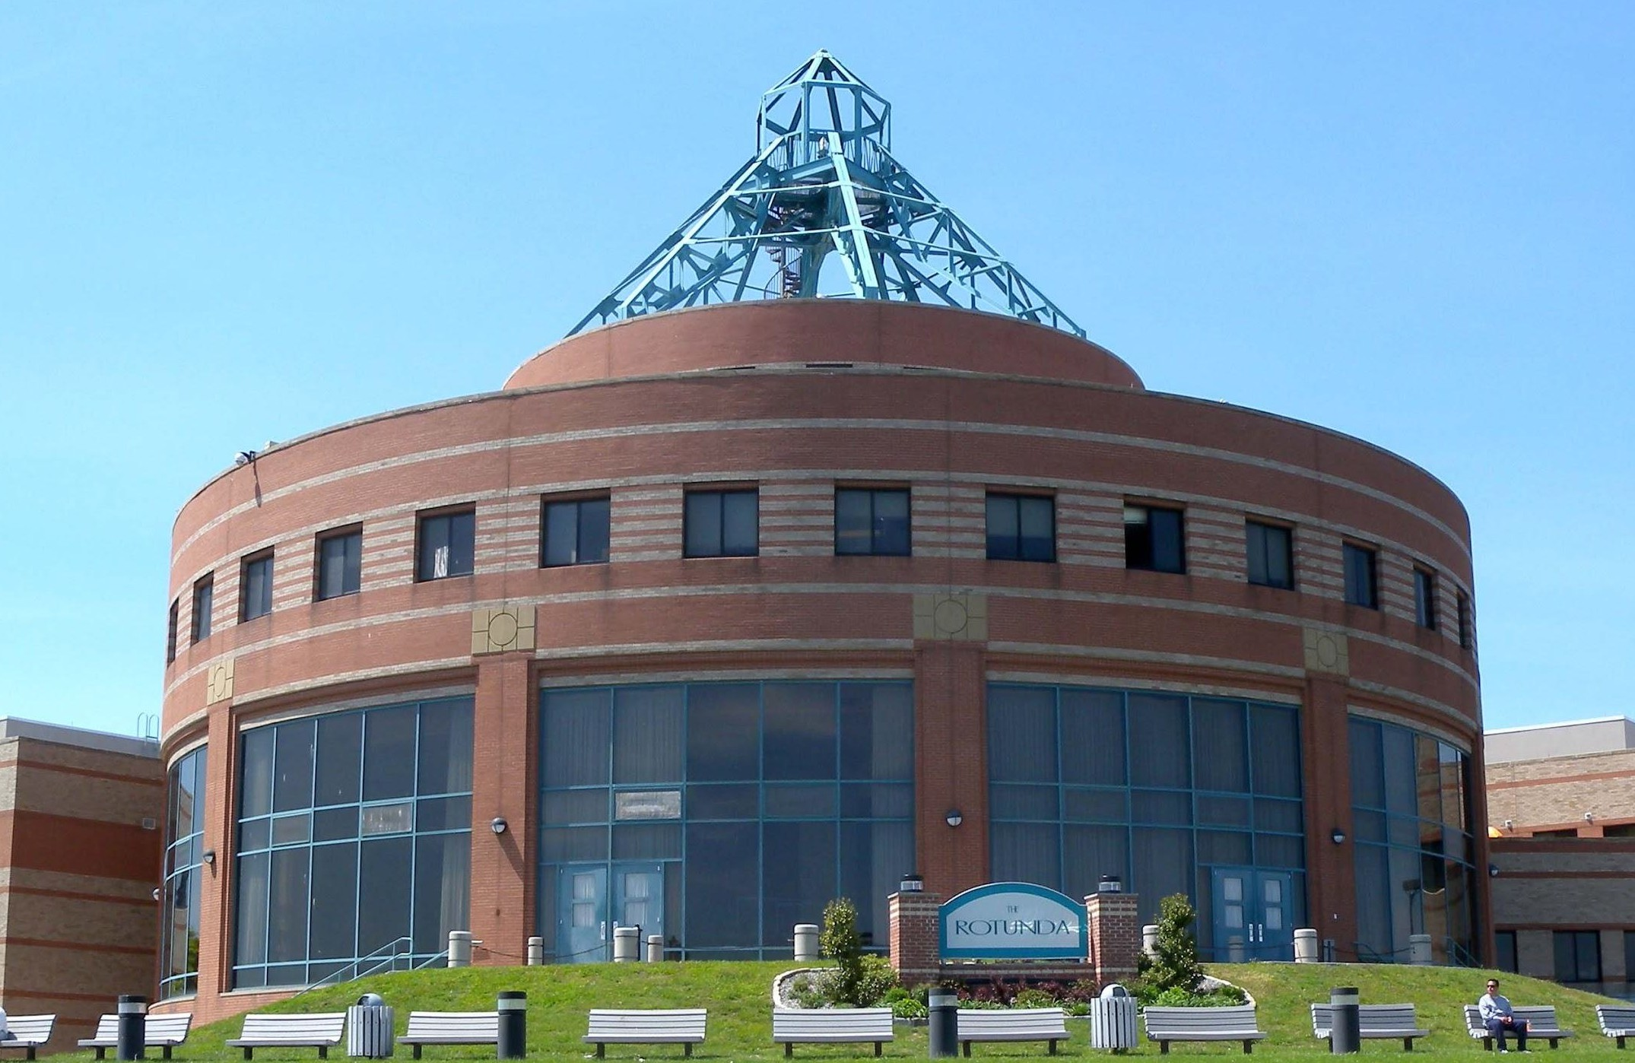



How to get tenure at these institutions
Research
Teaching

Research-Intensive Institutions (R)
Research & Teaching Focused (RT)
Teaching-Only

Institutions (T)

How to get hired at these institutions?

Qualiﬁcation  career.ucsf.edu/ACRA |  | Level 1 | Level 2 | Level 3 | Level 4
Publications | 77% Required | Candidate has produced a few papers, regardless of authorship or impact. | Candidate has produced ﬁrst author papers during postdoc and (12) PhD (regardless of impact) (13). | Candidate has produced ﬁrst author papers during postdoc and (12) PhD, with at least one paper contributing signiﬁcantly to the ﬁeld (14). | Candidate has produced ﬁrst author papers during postdoc and (12) PhD, at least one of which was published in Cell, Nature, or Science (15).
RT | 77% Required | 9% | 64% | 5%
R | 100% Required |  | 3% | 95% | 3%
 | 77% Required
Research Vision & Strategy | 77% Required | Research program is exciting  (16) with a clear direction and includes explicit, feasible steps to attain this direction over the ﬁrst couple of years. | Level 1 & There is an interesting, broad, research question that ﬁlls important gaps in the ﬁeld and provides direction for the next 5 to 10 years. | Level 2 & The research question is broken down into smaller, feasible projects that use appropriate methods to answer the question. | Level 3 & The candidate has demonstrated experience successfully implementing this or a similar vision independently. (17)
RT | 77% Required | 41% | 18% | 18%
R | 87% Required | 13% | 29% | 34% | 11%

^{Qualiﬁcation} Level 1 Level 2 Level 3 Level 4
career.ucsf.edu/ACRA

Funding Plan |  |  | Candidate can suggest speciﬁc funding agencies and program names to fund proposed research program. (18) | Level 1 & Proposed research program is ambitious and impactful enough to be funded by an R01 grant. (19) | Level 2 & Candidate has developed speciﬁc aims that can be realistically achieved with a ﬁrst R01 grant. (20) | Level 3 & Candidate has developed a funding plan beyond the ﬁrst R01 grant. (21)
 | RT | 45% | 45%
 | R | 68% Required | 8% | 24% | 34% | 3%
 |  | 59% Required
 | Research Independence | 59% Required | Candidate has the technical expertise to run their proposed research program independently. (22) | Level 1 & Candidate shows ability to lead a research program, by developing own ideas and new collaborations independently. (23) | Level 2 & Candidate’s proposed research program does not appear to be in competition with their current advisor’s. (24) | Level 3 & Candidate can provide evidence of independence through advisor’s recommendation letter.
 | RT | 59% Required | 27% | 23% | 5% | 5%
R |  | 82% Required | 11% | 32% | 24% | 16%
R |  | 92% Required | 24% | 5% | 32% | 32%

^{Qualiﬁcation} Level 1 Level 2 Level 3 Level 4
career.ucsf.edu/ACRA
Recommendati ons |  | 73% Required | Enthusiastic and personalized recommendations from both PD and PhD advisors. (25) | Level 1 & letters from other respected scientists who are well known by the search committee AND who know the candidate well. (26) | Level 2 & letters emphasize candidate’s ability to be successful as a principal investigator. | Level 3 & letters emphasize that the candidate shows the potential to become a leader in the ﬁeld.
 | RT | 73% Required | 59% | 9% | 5%
 | R | 92% Required | 24% | 5% | 32% | 32%

^{Qualiﬁcation} Level 1 Level 2 Level 3 Level 4
career.ucsf.edu/ACRA
Research Feasibility with Available Resources | 82% Required | Candidate demonstrates ability to develop a research program within the limitations of the start-up funds. (8) | Level 1 & Candidate demonstrates the ability to independently manage and run the equipment required for their research program. (9) | Level 2 & Research program is feasible in the institution’s research and geographic environment, which includes some minor constraints. (10) | Level 3 & Research plan is tailored to the non-R1 institution’s highly limited resources. (11)
RT | 82% Required | 14% | 9% | 36% | 23%
R | 66% Required | 16% | 26% | 24%
Verbal Communicatio n  of Research |  | Can present research clearly and eﬀectively to labmates. | Can present science clearly to scientists in the same  sub-discipline (for example, to other microbiologists). | Can present science clearly and eﬀectively to scientists outside of subﬁeld. | Can present science clearly and eﬀectively and can spark the interest of scientists outside of subﬁeld and non-PhD students.
RT | 73% Required |  |  | 14% | 59%
R | 87% Required |  | 3% | 61% | 24%

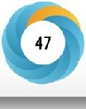
e
Cold Sprlr.g ttubor L1boutory
bioRxiv
THE PREPRINT SERVER FOR BIOLOGY
HOME I ABOUT I

SUBMIT I ALERTS/ RSS
I CHANNELS
[ Search
Advanced Search
New Results
Comment on this paper
()Previous
NextC)
The Academic Career Readiness Assessment: Clarifying training
expectations for future life sciences faculty
Posted November 06, 2019.
Laurence Clement,Jennie B. Dorman, G) Richard McGee
doi: https://doi.org/10.1 IOI /829200
This article is a preprint and has not been certified by peer review [what does this mean!].
P..J Download PDF
Iii Supplementary Material
l'JEmail
,+ Share
id Citation Tools
Abstract
Full Text
Info/History�
� Preview PDF
ARTICLE USAGE
am IDII
Subject Area

Scientific Commumcation and Educatmn
Article lifetime Last 6 months This month
Article usage: November 2019 to December 2019
Subject Areas
Show by momh
Abstract
Full-text HTML
PDF
All Articles
Total
1.719
291
453
Animal Behavior and Cognition
I
Biochemistry
Blogged by 1
Tweeted by 62
Bioengineering
Bioinformati<:s

Time to reﬂect on your developmental stage
- Go to our in-class activity/survey: bit.ly/GRAD201A
- Complete all questions 1 (on two pages) and stop at “wait for the instructor here”
- Share with a partner

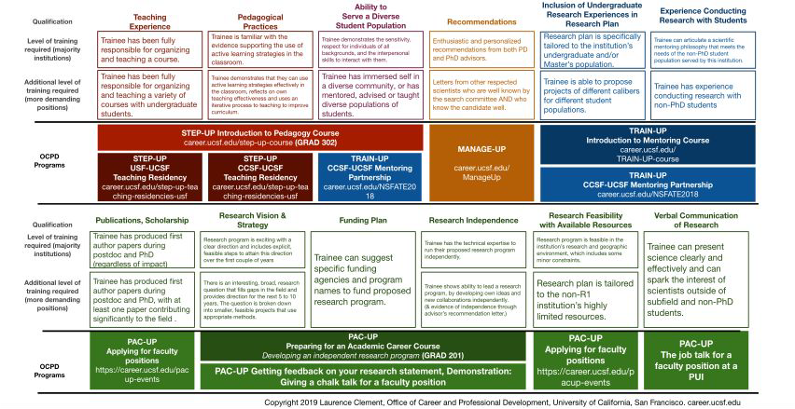
OCPD academic career programs are mapped to ACRA goals

bit.ly/ACRAroadmap



We asked faculty what they did to develop an independent research program when they were trainees.

HAVE A STRATEGY
- Take the time to plan your career path
- Select the right lab environment
- Stay open to multiple research directions
- Take the time to choose and design your projects
- Take the time to plan your projects early-on
- If you haven't done so yet, move to your independent project in the last few years of your training
- Calculate the resources needed for the projects
- Get your ﬁrst independent project funded

EVALUATE
- Get feedback on your project plans from your lab early-on
- Regularly track and assess progress on your project(s)
- Connect with faculty about your independent project
- Ask for critical reviews from faculty
- Address all critiques
- Identify and cultivate mentors and sponsors

CONVINCE
- Identify the big picture and target audience (funders, departments)
- Learn how to communicate your project
- Be proactive about promoting your work
- Use fellowship opportunities to have a discussion about independence with your PI


Common challenges faced by faculty who did succeed

Afraid to admit my career goals to my PI Perceived as an implementer of my PI’s ideas
Not having a discussion about independence

Not considering faculty on equal footing when engaging with them


Common challenges faced by faculty who did succeed
Relying on my PI's validation to know if I am ready for the next step
Getting wrong advice on how to spend my time in grad school/postdoc
Not knowing if I am qualiﬁed for a faculty position

Believing the idea I pitch is my life project


Common challenges faced by faculty who did succeed
Underestimating the time it takes to complete the project

Not knowing how to demonstrate potential impact of my work

Not being comfortable with the "PR" required

Not having a long term plan

Common challenges relate to systemic issue with graduate and postdoctoral training
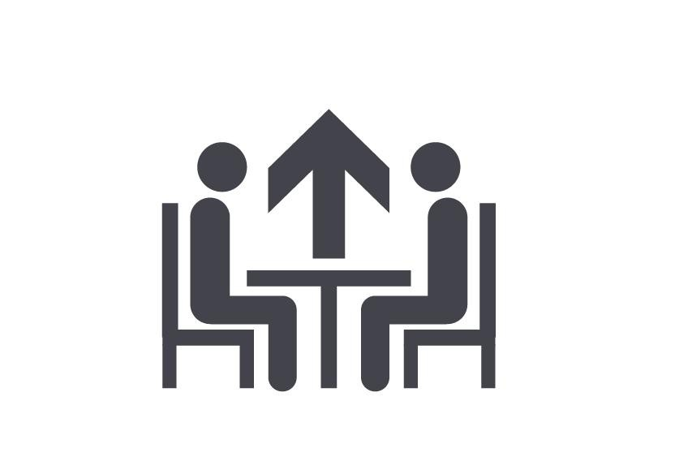
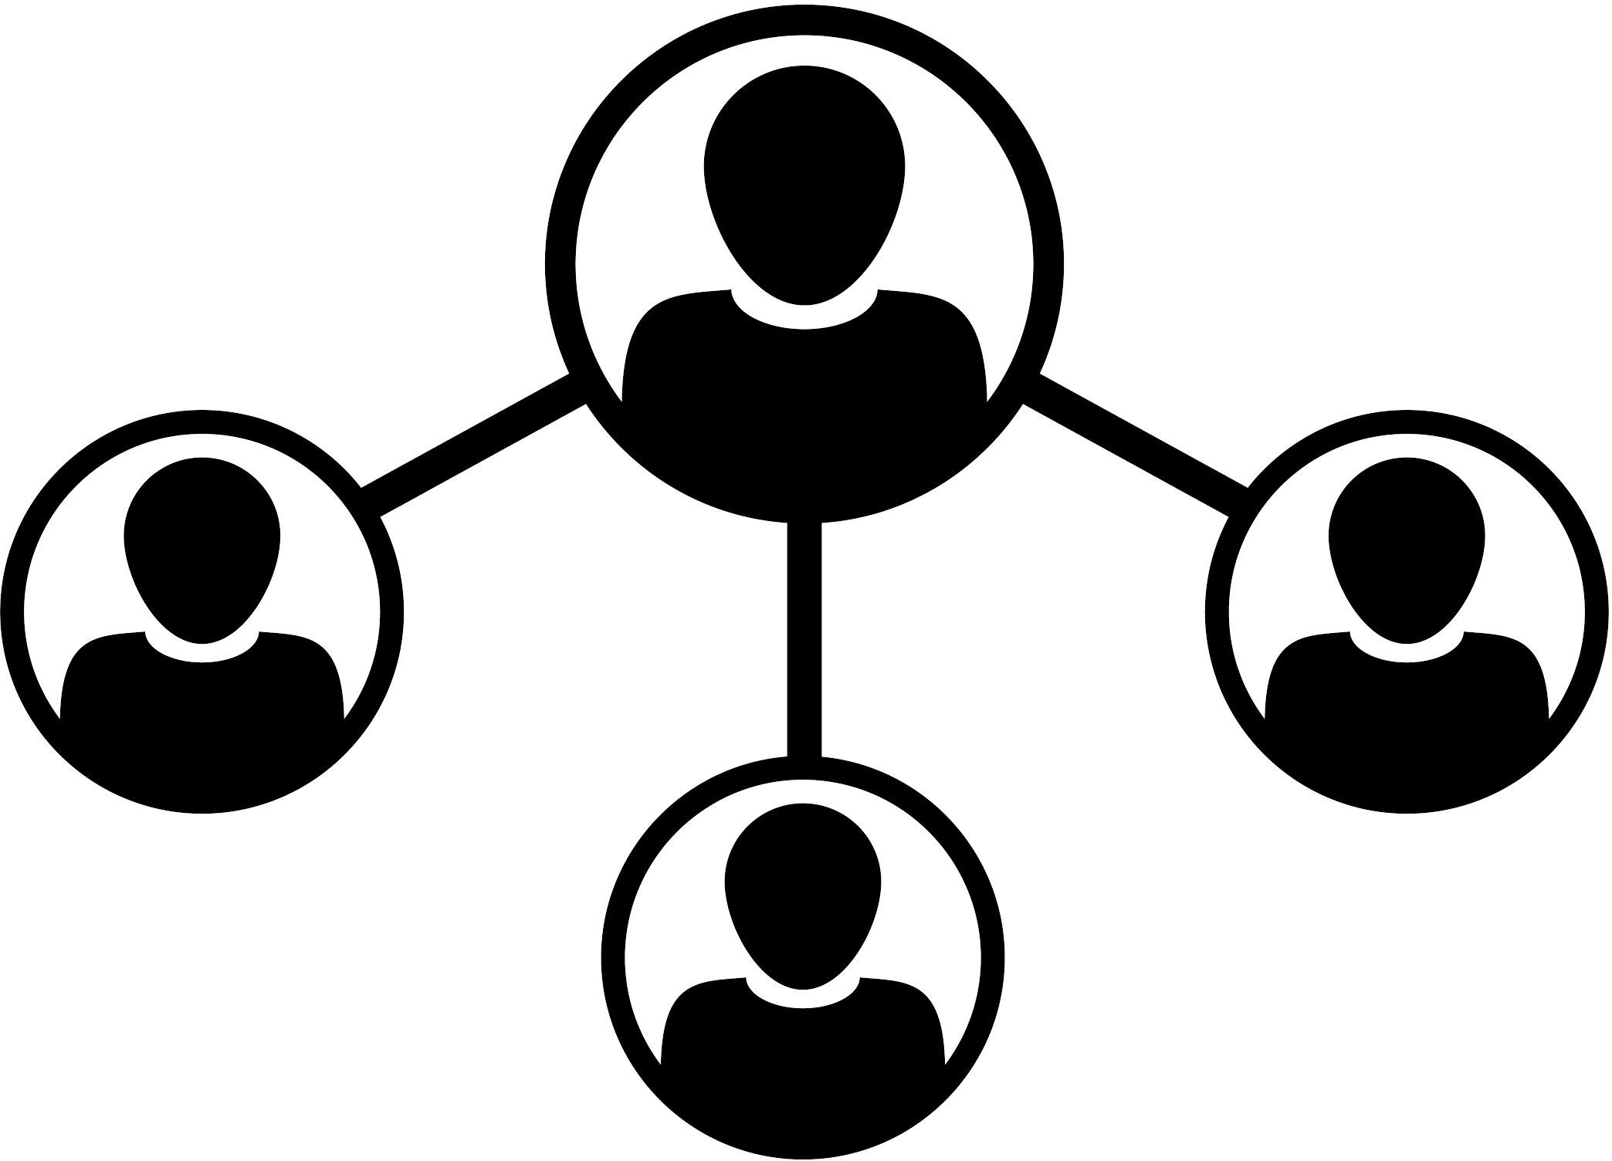

supervisor-employee
mentor-mentee
Afraid to admit my career goals to my PI
Perceived as an implementer of my PI’s ideas

No having a discussion about independence

Not considering faculty on equal footing when engaging with them
Relying on my PI's validation to know if I am ready for the next step
Getting wrong advice on how to spend my time in grad school/postdoc

Not knowing if I am qualiﬁed for a faculty position
Believing the idea I pitch is my life project

trainer-trainee
Underestimating the time it takes to complete the project
Not knowing how to demonstrate potential impact of my work

Not being comfortable with the "PR" required

Not having a long term plan

There are diﬀerent relationships for a research mentor and their trainee

Role** The traditional  mentor  (advisor) | Is responsible for… | When?
Role** The traditional  mentor  (advisor) | Career development Psychological support | When you are expected to support a mentee to attain their career goal or navigate professional challenges.
The educator (trainer) | Scientiﬁc knowledge Technical skills  Critical and analytical thinking  Identiﬁcation of creative projects | When your mentee is expected to learn new knowledge and skills for which you have expertise during their time with you, as part of an educational or training program.
The supervisor (manager) | Performance | When the performance, behavior and productivity of the mentee impacts your success or that of someone on your team, and you have the authority to hire, ﬁre, pay, and recommend someone for promotion.
The supervisor (manager) | Behavior  Productivity
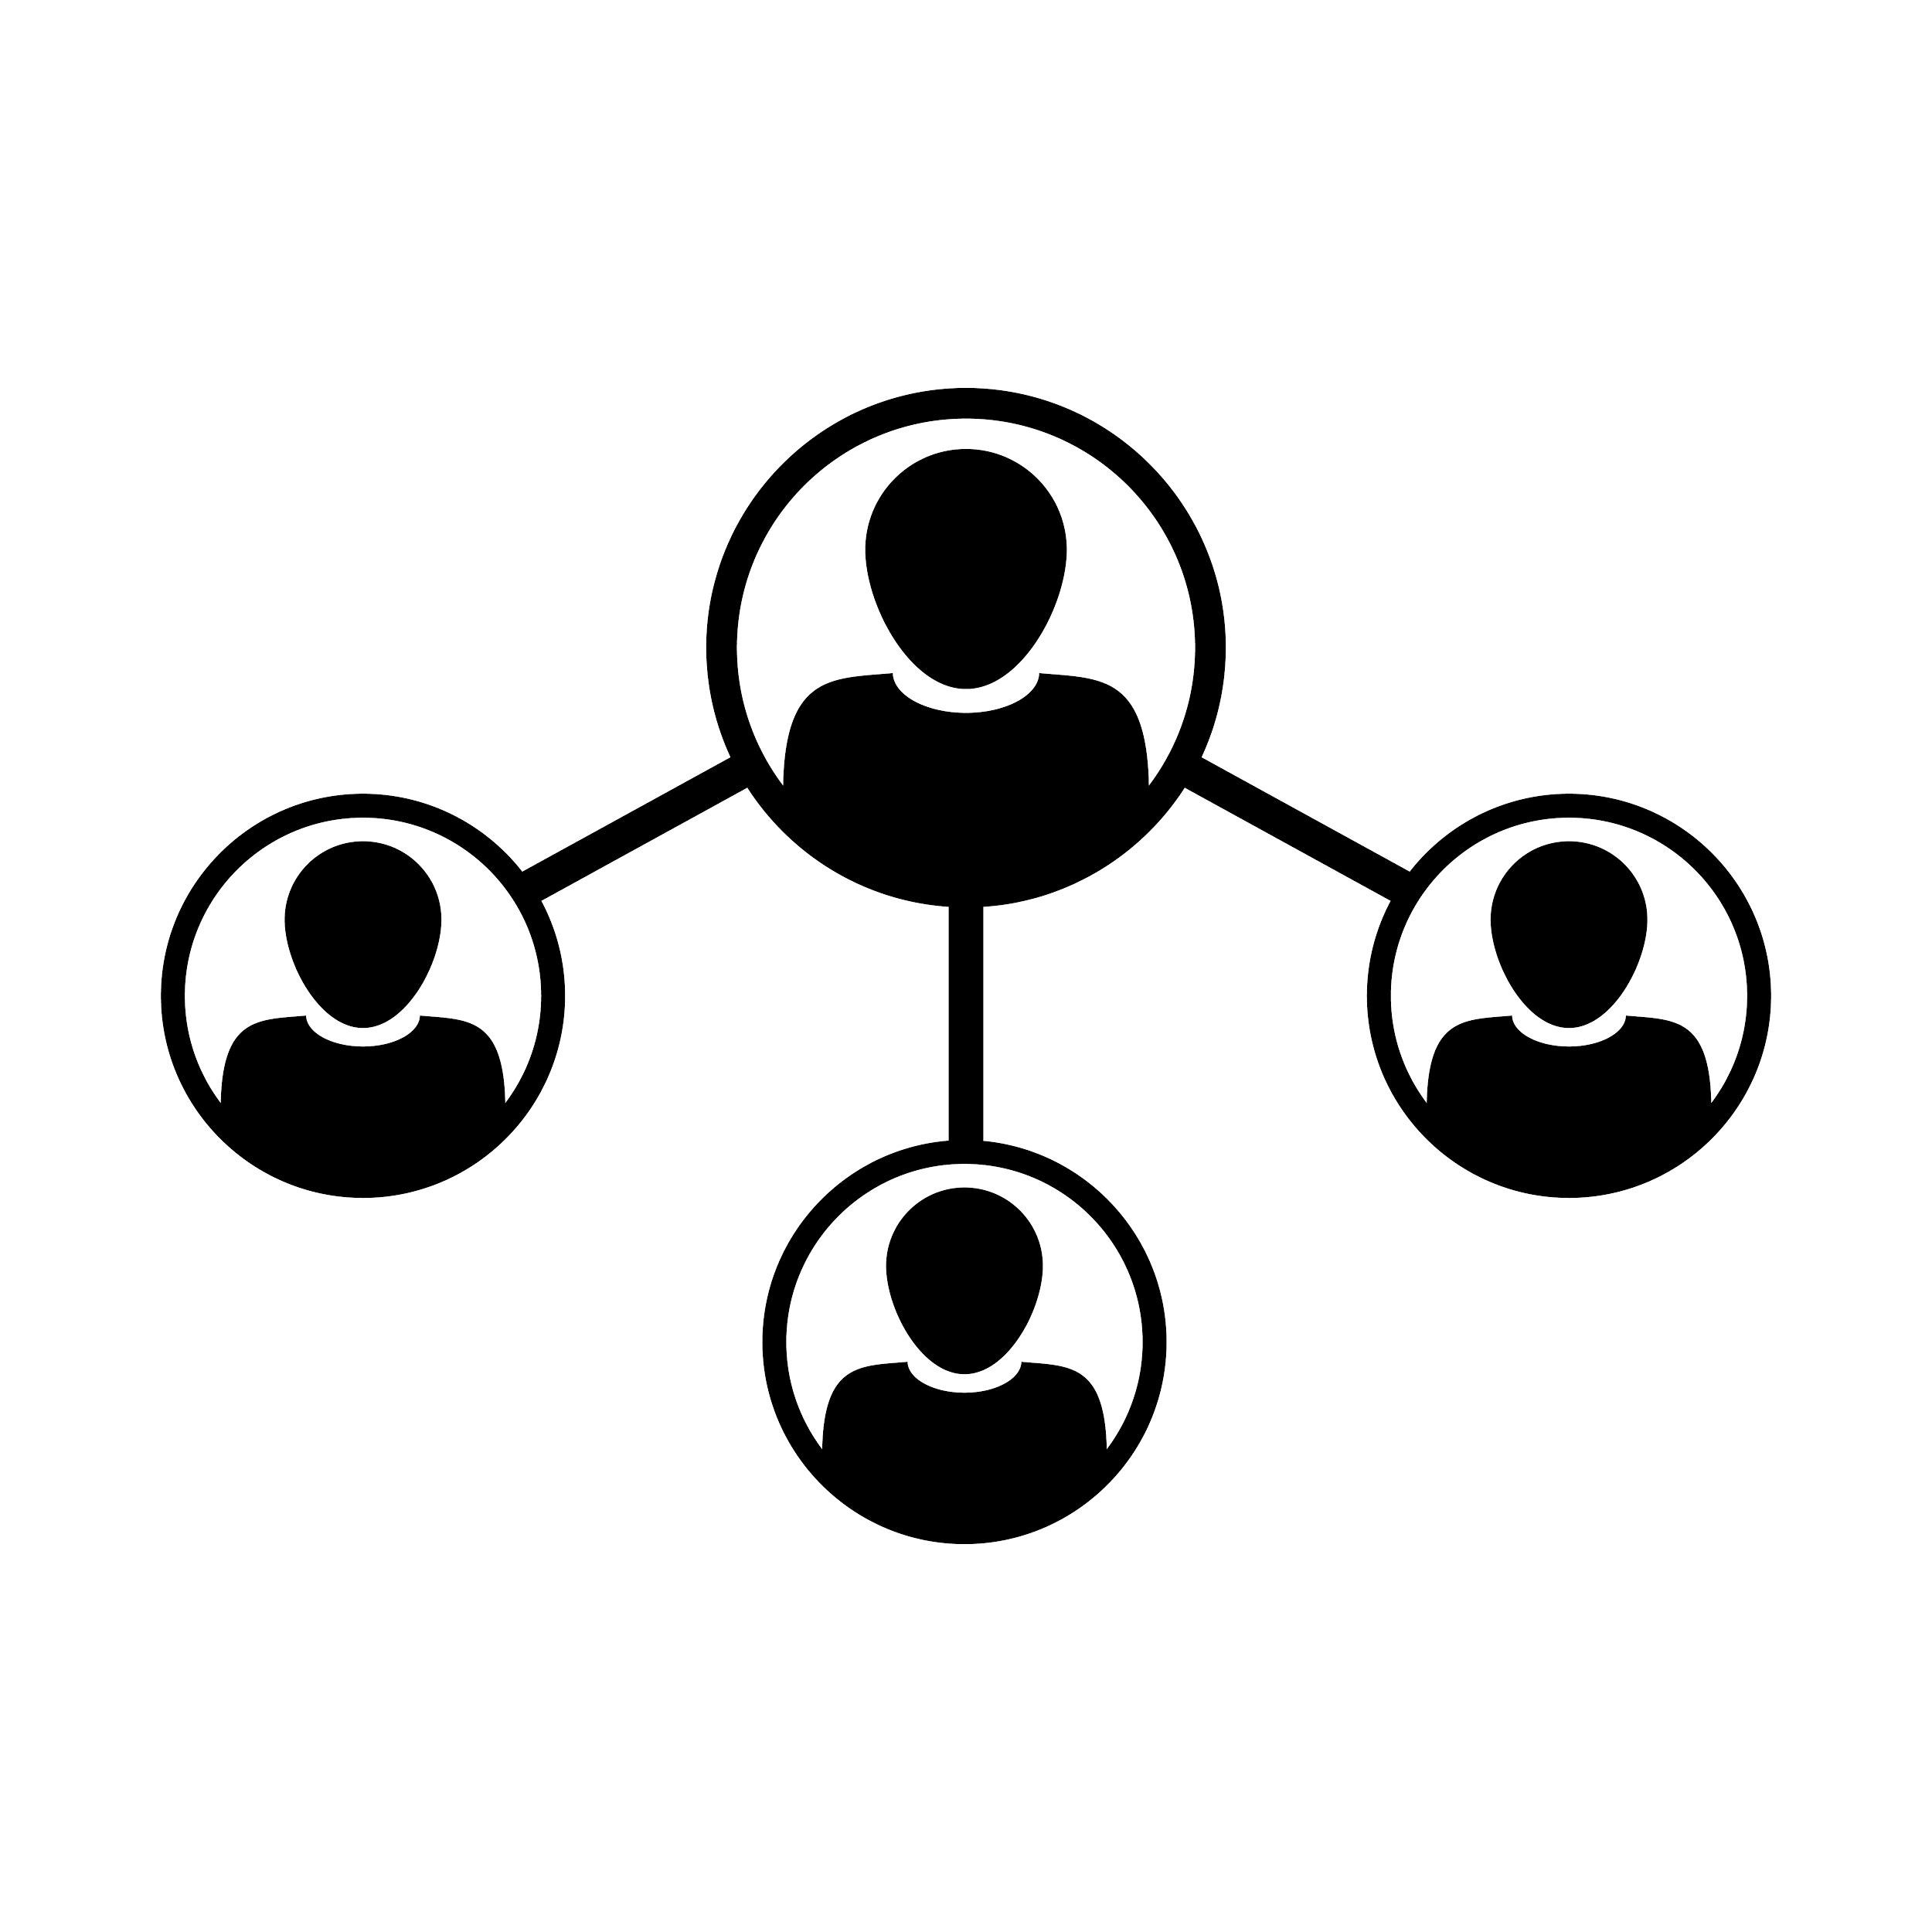
**Laurence Clement, Karen Leung, James Lewis and Naledi Saul, 2016

There are diﬀerent relationships for a research mentor and their trainee
When?
When you are expected to support a mentee to attain their career goal or navigate professional challenges.
When your mentee is expected to learn new knowledge and skills for which you have expertise during their time with you, as part of an educational or training program. When the performance, behavior and productivity of the mentee impacts your
success or that of someone on your team, and you have the authority to hire, ﬁre, pay, and recommend someone for promotion.
Role** The traditional  mentor  (advisor) | Is responsible for…  Career development Psychological support | Some of these roles are in conﬂict with each other
The educator (trainer) | Scientiﬁc knowledge Technical skills  Critical and analytical thinking  Identiﬁcation of creative projects | Some of these roles are in conﬂict with each other
The supervisor (manager) | Performance Behavior Productivity | Some of these roles are in conﬂict with each other

**Laurence Clement, Karen Leung, James Lewis and Naledi Saul, 2016

Common challenges relate to systemic issue with graduate and postdoctoral training
supervisor-employee
mentor-mentee
Afraid to admit my career goals to my PI
Perceived as an implementer of my PI’s ideas

No having a discussion about independence

Not considering faculty on equal footing when engaging with them
Relying on my PI's validation to know if I am ready for the next step
Getting wrong advice on how to spend my time in grad school/postdoc

Not knowing if I am qualiﬁed for a faculty position
Believing the idea I pitch is my life project

trainer-trainee
Underestimating the time it takes to complete the project
Not knowing how to demonstrate potential impact of my work

Not being comfortable with the "PR" required

Not having a long term plan

Time to reﬂect on own barriers
- Go to our in-class activity/survey: bit.ly/GRAD201A
- Complete questions 2 and 3 (on two pages) and stop at “wait for the instructor here”
- Share with a partner (what you feel comfortable sharing)

Faculty perspective 1:
Planning and selecting your projects as a graduate student
Isha Jain, PhD. Sandler Faculty Fellow Principal Investigator.

Notes from Isha’s talk: Choosing Projects

  - Choose at least 1 collaborative project
  - Re-evaluate projects regularly (4-6 months)
  - 1-2 high risk projects, 1-2 low risk projects
  - Every project has two “humps”
    - After 6 months: can I get a paper out of this?
      - What is the paper outline?
        - Figures
        - Narrative as bullet points
    - 3-4 years: is this going to have an important impact?

Notes from Isha’s talk: Day-to-day

  - Start the day with exciting science
    - Ie read the twitter feed of a favorite scientist
    - Or skim a few new papers
    - Instead of checking email
  - Take the time to plan: schedule it
  - Be deliberate about planning “down time”

Notes from Isha’s talk: Getting new ideas/developing your research

  - Attend talks outside your field
  - Read up on topics that are unfamiliar
    - Papers that are a one-paper-radius away from your project
      - After all, you’re trying to establish yourself in something DIFFERENT from what your PI studies!
  - Have an “ideas” book/document/OneNote
    - Over time you will accumulate hundreds of ideas, the best of which can fuel your first grants
  - Take the time to train in the skills you need before starting a lab
    - OCPD’s programs: TRAIN-UP to manage, hire, fire
    - Ask to be involved
      - Managing a budget
      - Talking with journal editors
      - Editing papers
      - Hiring people
    - Ask to be a corresponding author
  - Keep a whiteboard with 3 aims, add to it over time

Notes from Isha’s talk: Get help/connect/network
- In the last 3-6 months of her postdoc, Isha emailed 10-15 faculty she didn’t know in her region and asked for:
  - Feedback on her research program
  - Sponsorship for conferences
  - Hosting for talks
  - …gave her a foot in the door to “the club”
- When she had her first paper, she reached out to people she didn’t know
  - Some will turn into advisors/mentors
- Stay in touch with your thesis committee, grad school advisor, send them your paper
- Did a mini-sabbatical after postdoc, traveled in Europe visiting labs and giving talks
  - How to protect your ideas at this stage?
    - Is it a 2-way conversation? As you share more, do they share more too?
    - What’s their reputation?
- Have an online presence
- Submit abstracts for talks at conferences

Faculty perspective 2:
Developing and funding your independent research program
as an international postdoc
Ernesto Diaz-Flores PhD Assistant Adjunct Professor Pediatrics Department (UCSF) ernesto.diaz-ﬂores@ucsf.edu

Developing your project

- Discuss scope of project with your PI and colleagues
  - What is the major question in the field?
  - What is the question you want to address?
  - Does your work provide advances beyond the scope of your particular field/project?
- Delve into the literature and become a scholar in your field
- write your project in 1 page
  - Get it reviewed and learn the different aspects of it to shape your project
- Be mindful of your timeline:
  - Year 1 (learn), year 2 (produce and write), year 3 (apply: K99/R00, K,…)

Implementing your project

- Plan your project as a funnel (from top to bottom) and start your project (from the bottom up)
- Be creative and productive
- be systematic and efficient to generate compelling data
- Learn the craft:
  - how to write (competitive) grants, (high impact) papers and (winning) abstracts
  - how to give dynamic presentations
- Stay on top of literature: read reviews
- Set up collaborations (go to learn skills to other institutions)
- Attend conferences (large and small), seminars and workshops
- make beautiful visuals of your data (Prism, R, BioRender)

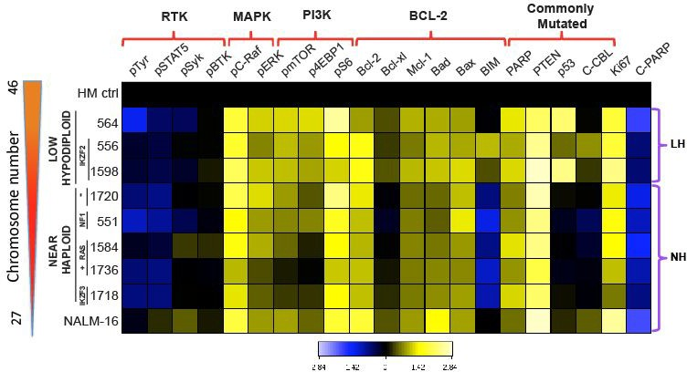
Examples of compelling visuals

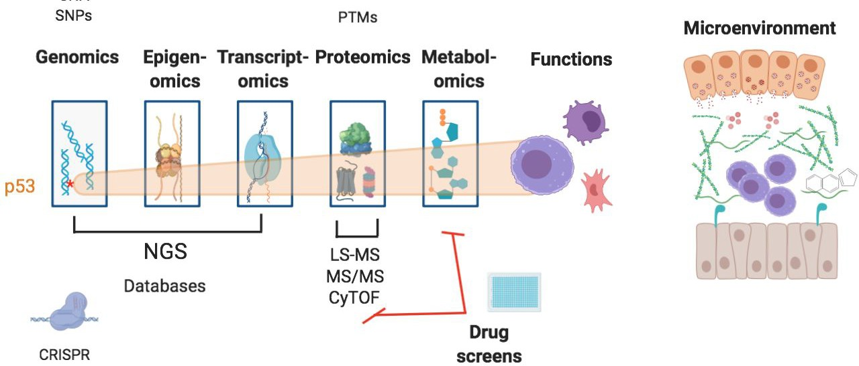
BioRender.com

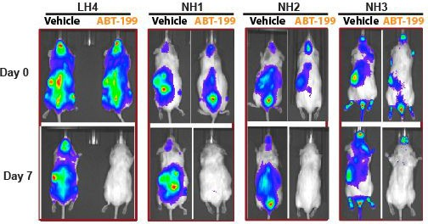
Diaz-Flores, et al., Cancer Research (2019)

Designing your independent research

- What is missing in your field?
- What is missing in your lab’s research that would benefit from another perspective
- Start working on it as a side project
- Set up your goals and be strategic on how to pursue them
- Become and expert in your field and start developing a track record
- Present it when you have a compelling case
- Establish independent collaborations
- Apply to a K99/R00 and other grant opportunities
- Think about the Oscars, you want to compete in the top categories

Funding your project as an international student

- Identify grant sources
  - From labmates
  - Foundations (use your keywords)
  - Pivot
  - Listservs
  - Companies
- Make a list to keep track
- Establish strategic collaborations
- Set up a reviewers committee

Example of a list of grant opportunities

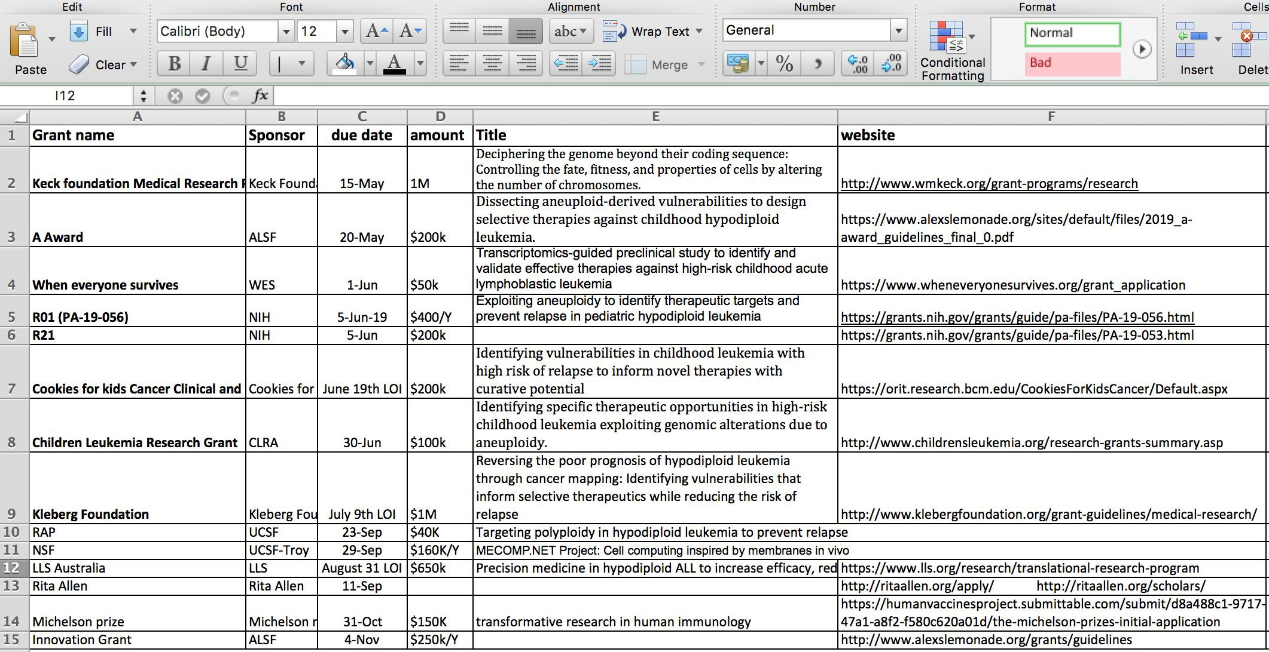

Special Recommendation: Excel at Writing

Learn to write Science in English:
- Grammar courses
- scientific writing courses
- get Grammarly

Learn to write competitive grants:
- learn to write compellingly Book resources:
  - "The elements of style" by Strunck and White
  - "Designing and writing scientific research papers" by Thomas Annesley
  - "Essentials of Writing Biomedical Research Papers" by Mimi Zeiger
  - "Publishing and Presenting Clinical Research" by Warren Browner
- Get them reviewed by peers and someone external

A final word: Remember that
the world would always be ready to embrace people with talent

ernesto.diaz-flores@ucsf.edu

Starting an independent career: Designing your project
Ernesto Diaz-Flores

Designing a research plan

- Step 1: Identify what you are most passionate, excited about. What is your scientiﬁc vision and mission?
- Step 2: Convince your target audience that they should care about your vision and your mission: impact, signiﬁcance, relevance of the work?
  - study section at speciﬁc funding org
  - hiring faculty at research institutions
- Step 3: Convince the audience that you can successfully lead this project on your own.
- Step 4: Determine if the environment, department, institution is conducive to your success.

Designing a research plan

Identify what you are most passionate, excited about. What is your scientiﬁc vision and strategy?
Passion: Be speciﬁc - avoid generalities like “I am passionate about biology or social sciences”. What are values drive your interests? “Someone I know had this disease, and my mission is to ﬁnd a treatment for this disease.”
Vision: What is the big picture goal of your future lab? “I want a lab where I would use proteomics to solve cancer-related biological challenges.”
Strategy: “I want to develop new tools in proteomics, because I believe that it will solve cancer-related biological challenges than genomics.”

Designing a research plan

Convince your target audience that they should care about your vision and your mission: impact, signiﬁcance, relevance of the work?
Relevance: Tailor to the funding context, or to what already exists. Instead of saying “I want to ﬁnd a new therapeutic targeting X protein,” which already exists, you say that “I will develop a project that will help understand X protein’s biology.”
Signiﬁcance: How novel is this? What is diﬀerent about your approach? What is your edge, your niche? “I will use Y technique in addition to the other things I do (that may not seem novel).”
Impact: How is this going to change your ﬁeld? “By better understanding the biology of X protein, our ﬁeld will be able to …. and ….”

Designing a research plan

Convince your target audience that they should care about your vision and your mission: impact, signiﬁcance, relevance of the work?
Impactful but not relevant:
We will deﬁne the crystal structure of X protein, but we don’t know where it is expressed and why this protein is important.

Designing a research plan

Convince the audience that you can successfully lead this project on your own.
Technical expertise: What technical expertise do you have to support this strategy? “I have experience in computational science in my graduate work, and have developed animal experimentation skills in my postdoc.”
Scientiﬁc expertise: What scientiﬁc expertise do you have to support this strategy? “My understanding of the physiology of type 2 diabetes and the neural pathways in food intake equip me to address this issue.”
Productivity: What have you accomplished as a trainee? What did you publish? Is it potentially impactful? Have you secured fellowships or grants?

Designing a research plan

Determine if the environment, department, institution is conducive to your success.
Physical resources: What physical resources will be available for you in this department, at this institutions? Do you have everything you need to successfully run your program?
Scientiﬁc experts: Will your colleagues be able to mentor you or support you? Have they been productive and successful in their own work?
Collegiality: How collegial is your department? Have your predecessors succeeded in this environment?

Working Lunch
Write your research plan.
You will share it with others after lunch.

Working Lunch
Write your one-page research plan, to share after lunch.

- Step 1: Identify what you are most passionate, excited about. What is your scientiﬁc vision and mission?
- Step 2: Convince your target audience that they should care about your vision and your mission: impact, signiﬁcance, relevance of the work?
  - study section at speciﬁc funding org
  - hiring faculty at research institutions
- Step 3: Convince the audience that you can successfully lead this project on your own.
- Step 4: Determine if the environment, department, institution is conducive to your success.

Group work
Get feedback on your plan
Laurence Clement

Improving your research plan: Share in groups of 3
- Present for 4 minutes to your peers
- Peers discuss it for 10 minutes: ask questions, share their reaction, make suggestions

- Criterion 1: Is the scientiﬁc vision and mission clear?
- Criterion 2: Is it clear what is the impact, signiﬁcance, relevance of the work?
  - study section at speciﬁc funding org
  - hiring faculty at research institutions
- Criterion 3: Is it clear that the strategy can get them to their outcome? Is it clear that they can successfully lead this project on their own?

- Criterion 4: Is it clear whether the environment, department, institution is conducive to their success? Can they do this work with the expertise and resources available to them?

Faculty perspective 3 & Lecture: Using faculty feedback to improve the fundability of your research program
Felice Dunn, PhD, Assistant Professor

Workshop
Your plan for identifying and reaching out to faculty
Laurence Clement

The “feed forward” process
Suggested by Keith Yamamoto, PhD,
UCSF Vice Chancellor for Science Policy & Strategy

- Identify 3 faculty and invite them to be part of your mock review committee
- First meeting (90 minutes)
  - Do not provide anything in writing.
  - Discuss your ideas.
  - Allow them to “grill” you on why this is important, what diﬀerence it would make if it was done.
  - Listen actively to their questions, concerns, suggestions. Observe their disagreements.
  - Use what you learned to write one page of three to ﬁve speciﬁc aims, addressing their points.
- Second meeting:
  - Send your 1-pager with enough notice for them to read it
  - Listen actively to their debate, let them grill you further.
  - If they don’t like it, throw it away and start again.
  - If they like it, you are good to go - write your full proposal.
Source: Dr. Yamamoto and https://www.nigms.nih.gov/research/application/pages/tips.aspx

The “feed forward” process
Suggested by Keith Yamamoto, PhD,
UCSF Vice Chancellor for Science Policy & Strategy

- Identify 3 faculty and invite them to be part of your mock review committee
- First meeting (90 minutes)
  - Do not provide anything in writing.
  - Discuss your ideas.
  - Allow them to “grill” you on why this is important, what diﬀerence it would make if it was done.
  - Listen actively to their questions, concerns, suggestions. Observe their disagreements.
  - Use what you learned to write one page of three to ﬁve speciﬁc aims, addressing their points.
- Second meeting:
  - Send your 1-pager with enough notice for them to read it
  - Listen actively to their debate, let them grill you further.
  - If they don’t like it, throw it away and start again.
  - If they like it, you are good to go - write your full proposal.
Source: Dr. Yamamoto and https://www.nigms.nih.gov/research/application/pages/tips.aspx



Why would people in your professional community help you?
- Because you’re doing interesting work
- Because your work could forward their goals
- To share their knowledge
- Because they have hard won lessons
- Because they wish someone had helped them
- To repay a favor
- To help a friend
- They have the time/interest to do so
- Because they consider it part of their job
- You have an aﬃnity to each other; they see themselves in you
- Because they like something about you
- Because you remind them of someone
- Because you asked respectfully
2018 © The Regents of the University of Califormia. Do not reprint without permission. naledi.saul@ucsf.edu
In Your Academic/ Professional World

Colleagues

Collegiality

Collaboration
Curiosity

Productivity
Affinity
Respect

You can talk to anyone in your professional community, but you need to modulate how you speak with them

The farther people are from you, the more clear and concise you need to be

- People you don’t know at all
- People who are senior in their ﬁeld
- People who know your friends or colleagues
- People 1-2 stages ahead in their careers










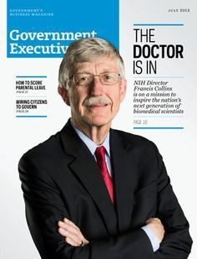
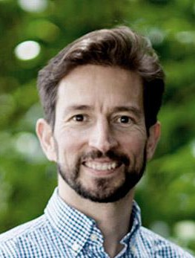
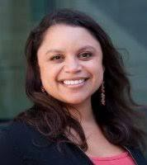
  - People you know
  - People who are the same stage in their career
2018 © The Regents of the University of Califormia. Do

not reprint without permission. naledi.saul@ucsf.edu

Application Materials ^{Dear} ^{Dr.} ^{Franklin,}
I know it’s been a while, and I hope you’re well. I’m applying

Things to note
- What? Get feedback on statements (research, teaching, diversity)

Who?
  - Someone who can critique your work with an ‘insider’s eye’.
  - You do not have to know this person well.
  - You do not need to like this person.

Why? Determine whether your statement is compelling.
- How? You can use our ACRA to guide the discussion (for e.g. you may need feedback on your vision, strategy, rationale, fundability, structure)
for tenure track R1 positions and would like to ask if you would consider reviewing my research statement.
It would be extremely helpful to get perspective on my research program, because of your work on X. I would be grateful for any feedback you find necessary, but in particular your thoughts on the scope of my work and it’s potential fundability would be most welcome.
Currently, I’m preparing materials for UPENN’s Biology department and Harvard’s Biochemistry department. I’ve attached my materials to this email. If you are able, I defer to your preferred style of giving feedback (by email, in person, on the phone, etc.).
Thank you for considering my request. Best,
Albert Einstein


2018 © The Regents of the University of Califormia. Do not reprint without permission. naledi.saul@ucsf.edu

Where are you in your development?
1
2
3
4
5

I understand the research program expectations that faculty hiring committees have of candidates |  | I can describe the successful components of a research program |  | I have identiﬁed a unique research niche that would distinguish me from other scientists in the ﬁeld |  | I have developed a research proposal with speciﬁc aims |  | I have presented my proposal to faculty (in writing or orally) and have received critical feedback that can help me improve it

1 2 3 4 5

I understand the research program expectations that faculty hiring committees have of candidates
I can describe the successful components of a research program
I have identiﬁed a unique research niche that would distinguish me from other scientists in the ﬁeld
I have developed a research proposal with speciﬁc aims
I have presented my proposal to faculty (in writing or orally) and have received critical feedback that can help me improve it

Someone who can share how they developed their program

Your stage of development and your ask
Someone who could help you brainstorm ideas for projects
Someone who could help you define specific aims
Someone who could provide critical feedback on your proposal

Workshop:
Your plan for identifying and reaching out to faculty

- Identify 3 faculty and invite them to be part of your mock review committee

  - Why are they the most appropriate people? What value, perspective will they bring to the proposal?

  - What concerns do you have about approaching them? How can you overcome your concern?

  - What will be your ask to them? What language will you use to invite them?

Source: Dr. Yamamoto and https://www.nigms.nih.gov/research/application/pages/tips.aspx

Assignment, due next session
- Finish your research plan using the feedback received today (to turn in next session, for credit students)
- Identify 3 faculty members to ask for support that matches your level of development
- Prepare to present your updated plan in 10 minutes in groups of 3 using a board (no slides!)
(Watch the video of Seemay Chou’s Chalk Talk Demonstration at bit.ly/ChalkTalkdemo, also linked on Syllabus)

